grab~

Abridged Software Requirements Specification

Version 1.0

October 25th, 2019

Austin Franklin
Software Module Designer

Prepared for
MUS 4745—Computer Music
Instructor: Edgar Berdahl
Fall 2014

1. General Description
Grab~ is an object/bpatcher that allows you to loop record audio into a buffer, and then recall audio for playback using the waveform~ object inside that buffer in real time. It can be used as a bpatcher or as an abstraction, giving the user more control over how the object is implemented within a larger framework. The software will help improve workflow in max by helping to consolidate the process of recording and playback of audio into one object/bpatcher, and it will be beneficial for experimenting with different types of signal processing.

2. Specific Requirements
2.1 Functional Requirements
2.1.1 Ability to playback audio from the buffer
It should be possible to grab audio from a buffer using the pitch value scaled to the length of the buffer.
2.1.2 Ability to change playback speed in real time
The object should have the ability to change the playback speed of the grabbed audio
2.1.3 Ability to easily change buffer size
The object will allow the user to change the buffer size by sending a number into the inlet.

2.2 Inlets and Outlets
2.2.1 Inlet #1 – Audio In
The audio signal to be recorded will go into the leftmost inlet.
2.2.a Outlet #1 – Audio Out
This outlet will output the grabbed audio from the buffer.

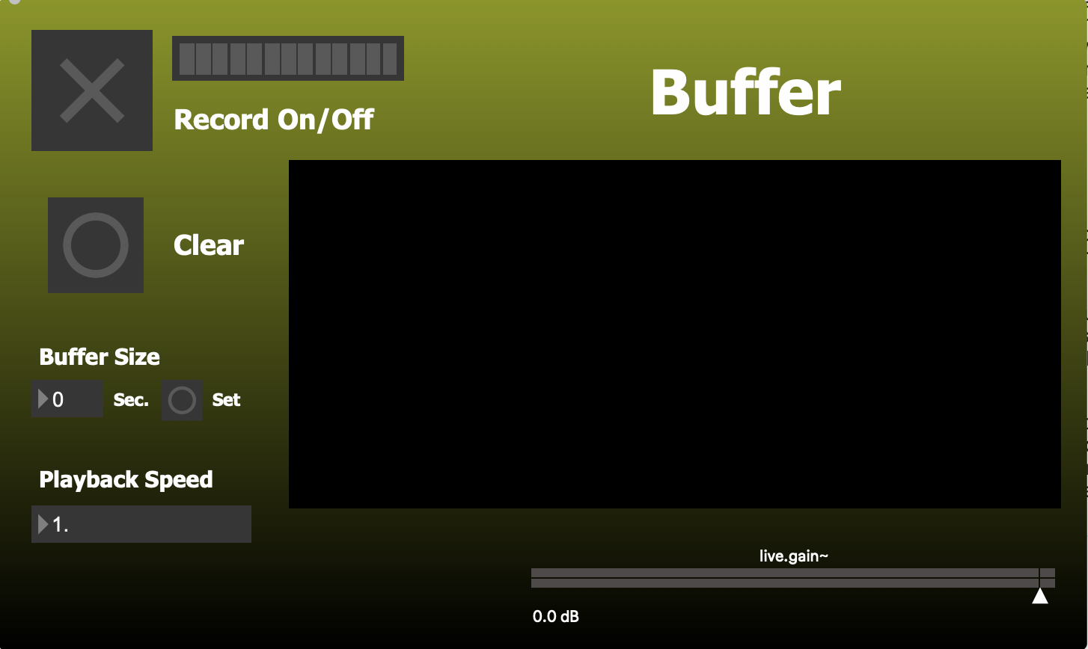
2.3 External Dependencies
There are no external dependencies.

3. Testing
3.1 Test Patch 1
Since the patch has a user interface, only one test patch will be needed. This patch will test the grab~ object on its ability to:

- be used as both an abstraction and a bpatcher.

- Change playback speed in real time.

- Easily change the buffer size.

